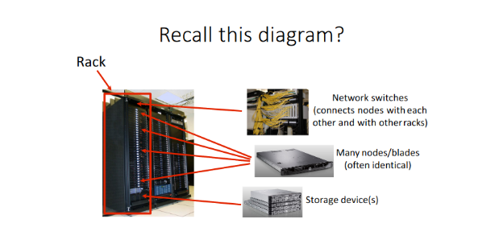High Performance Cluster ->Architecture of cluster

Remember that a rack consists if network switches, many nodes, and storage devices.

Evolution from: PC -> Servers -> Clusters -> Tons of clusters = Data Center

* **Cluster-**
  + Group of machines interconnected to work together as single system
    - Group of inter-connected cpus that work together to perform computationally intensive tasks. Each cpu referred to as a node.
  + *Nodes*
    - Individual machines in a cluster
  + *Head/Master Node*
    - Connected to both private network of cluster and public network.
    - Used to access given cluster.
    - Responsible for providing user env to work and distributing task among other nodes.
    - Usually has small number of head nodes, and large number of compute nodes.
  + *Compute Nodes*
    - Connected to only private network of cluster, generally used for running jobs assigned by head nodes.
  + TYPES OF CLUSTERS:
    - *Storage*
      * Provide consistent file stem image
      * Allow simultaneous read and write to single shared file system
    - *High-Availability*
      * Provide continuous availability of services by eliminating single points of failure
    - *Load-Balancing*
      * Send network service requests to multiple cluster nodes to balance requested load among cluster nodes
  + BENEFITS OF A CLUSTER
    - Reduce cost
    - Huge Processing Power
    - Scalability
    - Used for climate modeling, protein folding, data analysis, drug discovery…
  + CPP
    - Has high performance computing cluster
    - Runs HPE HPC Software Stack
  + Networking plays a HUUUUGE role.
  + Communication MUST be fast, can’t depend on regular ethernet.
  + Next Lesson (DAS, SAN, NAS)